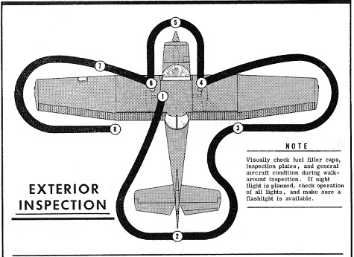

1) Remove external aileron control locks (if installed)
Master ON – Lower Flaps – Check Fuel Quant. – Master OFF
Remove control lock – Check Mags OFF – Fuel valve ON
Drain Fuel sample from left wing
2) Check: Tailcone
Check: Empennage
Remove tail tie-down
Remove tail gust lock (if installed)
3) Drain Fuel sample from right wing
Check: Flap – Aileron – Wingtip – Wing
Remove wing tie down
4) Check: Tire – Brake – Fuel Quantity - Fuel Cap
Drain belly fuel sample
5) Check: Oil level (4 qts. Min.) – Drain Fuel sample
Check: Nose gear – Strut – Air Filter – Prop – Spinner – Cowl
6) Check: Static source – Fuel Quantity - Fuel Cap – Tire – Brake
7) Check: Pitot tube – Fuel vent – Stall warning opening
Remove wing tie down
8) Check: Landing lights – Wing – Wingtip – Aileron – Flap
Master ON – Raise Flaps – Master OFF

